BansilalRamnathAgarwalCharitableTrust’s

VishwakarmaInstituteofTechnology, Pune-37
(AnautonomousInstituteofSavitribaiPhulePuneUniversity)


Department of Multidisciplinary Engineering

Division | AIML-A
Batch | B2
GR-no | 12414334
Rollno | 49
Name | Bhagat Rishikesh Vijay

- Assignment No. 4
- Title – Using Naïve Bayes theorem to classify emails as Spam/NotSpam
- Theory
1. Introduction
Naive Bayes is a supervised machine learning algorithm mainly used for classification tasks. It is based on Bayes' Theorem, which explains how the probability of a particular class can be updated when new information becomes available.
The algorithm is called naive because it assumes that all features are conditionally independent of one another when the class label is known. Although this assumption is often unrealistic in real-world datasets, Naive Bayes is still effective in many practical applications, particularly those involving text data.
Common applications of Naive Bayes include:
- Spam email and message detection
- Sentiment analysis
- Text and document classification
- News categorization
- Medical diagnosis
- Recommendation systems
2. Bayes' Theorem
Bayes' Theorem forms the mathematical basis of the Naive Bayes classifier. It calculates the probability of a class based on the observed features.
The formula is:
Where:
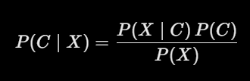

- (P(C\mid X)) — Posterior Probability: The probability of class (C) after observing the features (X).
- (P(X\mid C)) — Likelihood: The probability of observing the features (X), given class (C).
- (P(C)) — Prior Probability: The probability of class (C) before considering the observed features.
- (P(X)) — Evidence: The overall probability of observing the features (X).
3. Naive Bayes Assumption
Consider a message represented by three features:
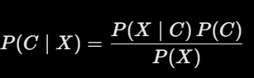
Naive Bayes assumes that these features are conditionally independent given the class (C). Therefore, their joint probability can be expressed as the product of their individual probabilities:
For a dataset containing (n) features, the equation becomes:
By applying this assumption to Bayes' Theorem, we obtain:
The classifier calculates this value for each possible class and predicts the class with the highest posterior probability.
4. Working of Naive Bayes
The Naive Bayes classification process generally consists of the following steps.
Step 1: Calculate the Prior Probability
The prior probability of each class is determined using the number of training samples belonging to that class.
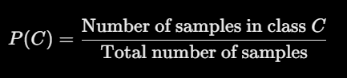
For example, suppose a dataset contains 100 messages, of which 60 are spam and 40 are not spam.
P(Spam)= 6/100 =0.6
Similarly, P(Not Spam)=0.4
Step 2: Calculate the Likelihood
Likelihood measures the probability of observing a particular feature when a given class is known.
For example, (P(\text{Free}\mid\text{Spam})) represents the probability that the word “free” appears in a message classified as spam.
Step 3: Calculate the Posterior Probability
Bayes' Theorem is applied to estimate the probability of each class based on the observed features.
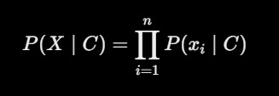
Step 4: Select the Class with the Highest Probability
The algorithm compares the posterior probabilities and assigns the message to the class with the highest value.
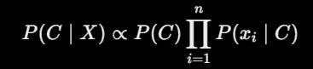
Since the probability of spam is higher, the predicted class is Spam.
5. Advantages of Naive Bayes
- Simple to understand and implement.
- Computationally efficient for training and prediction.
- Performs well with high-dimensional datasets.
- Particularly useful for text classification tasks.
- Requires comparatively little training data.
- Supports classification involving multiple classes.
- Works efficiently with sparse data, such as document-term matrices.
- Provides probability estimates for predicted classes.
6. Disadvantages of Naive Bayes
- The conditional independence assumption may not hold in real-world data.
- Strong correlations between features can reduce classification performance.
- The zero-frequency problem may occur when a feature has never appeared with a particular class; smoothing techniques such as Laplace smoothing can address this issue.
- It may fail to capture complex relationships between features.
- Its predicted probabilities may not always be well calibrated.
- Other machine learning algorithms may achieve better results on certain datasets.
7. Applications of Naive Bayes
Naive Bayes is widely used in applications such as:
- Spam detection and email filtering
- Sentiment analysis of reviews and social media posts
- News and document classification
- Language identification
- Text categorization
- Medical diagnosis support
- Recommendation systems
8. Conclusion
Naive Bayes is a simple, fast, and effective supervised learning algorithm based on Bayes' Theorem. Its assumption of conditional independence makes the calculations efficient, particularly for high-dimensional and text-based datasets. Although this assumption can limit its performance when features are strongly related, Naive Bayes remains a useful choice for many classification problems.

